**QUESTION 1: (Describing large data)**

We decided to analyze our project data for static user characteristics. The data is from a stream of usage feedback sent from a mobile app. Raw data is reported from user devices and collected in a comma-delimited text stream which describes user characteristics, actions, and timestamp. Raw data sample after formatting:

ID Age Sex Location Action Time Hardware

1 22129605 24 F 1000 2013-06-01 07:00:38 Y

2 22129605 24 F 1000 2013-06-01 08:05:41 Y

3 22129605 24 F 1000 2013-06-01 08:23:04 Y

4 22129605 24 F 1001 2013-06-01 07:12:42 Y

…

1. The *60MB* of usage data contains over *1.6 million rows*, representing activity of *12,991 unique* *users* between *06/01/2013* and *09/15/2013*.
2. 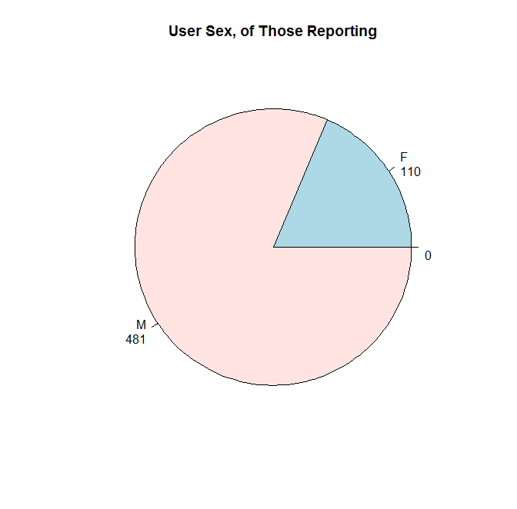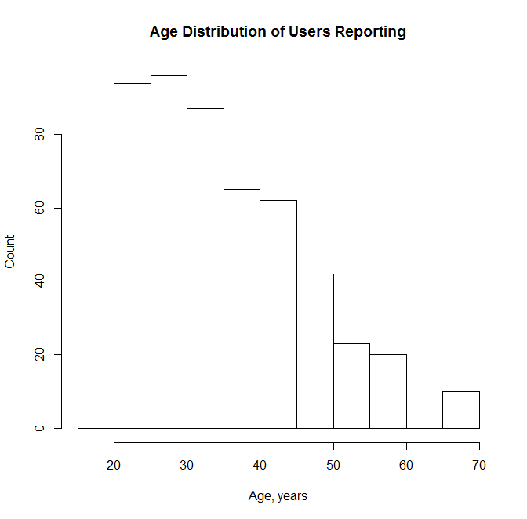While the data contains demographic information, only *4.5%* of users reported gender and *4.2%* reported Age (mean of *34.5 years*, median *34*). Of those reporting, the age and gender distributions are below:

1. An optional hardware device is available to pair with the app. *72.6%* of users have this hardware.
2. During the analysis window, each user has accumulated a number of actions as distributed below:

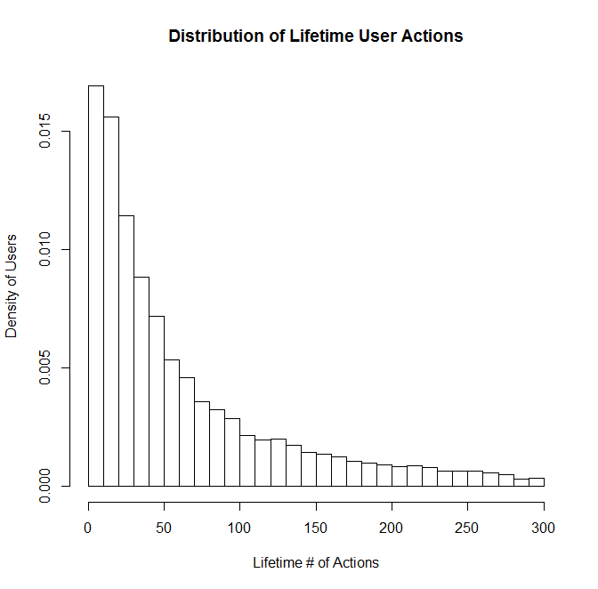

1. During the window, the average user’s total activity span lasted a number of days as distributed below:

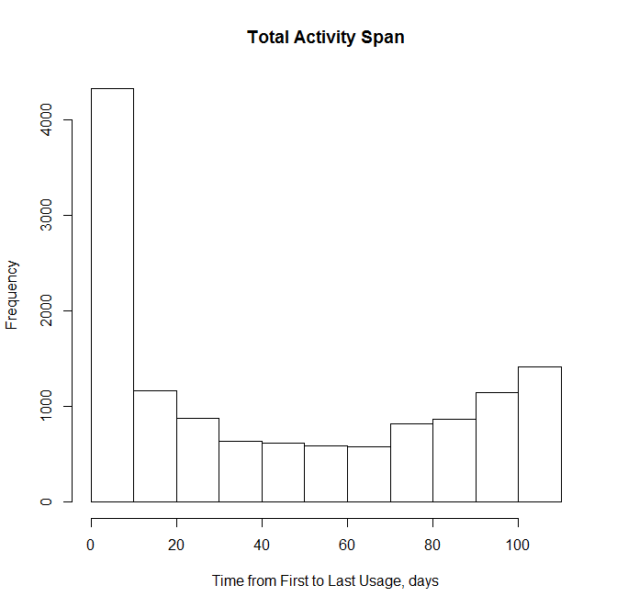

**QUESTION 2 (Find relationships)**

Below is a section of the exchange rate data for 6 countries:

DATE US Egypt Greece Hong.Kong India Italy Netherlands

1 1/1/50 1 0.3481407 0.04399120 5.71 4.7629 0.3226230 1.723911

2 1/1/51 1 0.3482420 0.04399118 5.71 4.7629 0.3222620 1.724365

3 1/1/52 1 0.3482420 0.04399118 5.71 4.7629 0.3222105 1.724819

4 1/1/53 1 0.3481407 0.07621422 5.71 4.7629 0.3222105 1.724365

5 1/1/54 1 0.3481407 0.08804109 5.71 4.7629 0.3222105 1.724365

6 1/1/55 1 0 .3482420 0.08804109 5.71 4.7639 0.3222105 1.724365

This data can be downloaded in .CSV format from the St. Louis Fed, or alternatively we can use QUANTMOD to pull from the FRED as a source:

getSymbols(c("DEXCAUS", "DEXCHUS", "DEXINUS", "DEXJPUS", "DEXUSEU", "DEXUSUK"), src='FRED')

Below is a time series of these exchange rates, both superimposed and as a plot matrix:

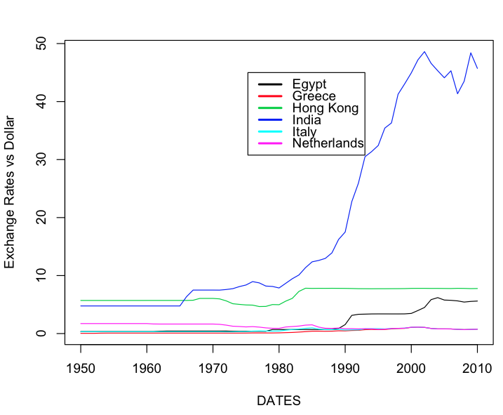

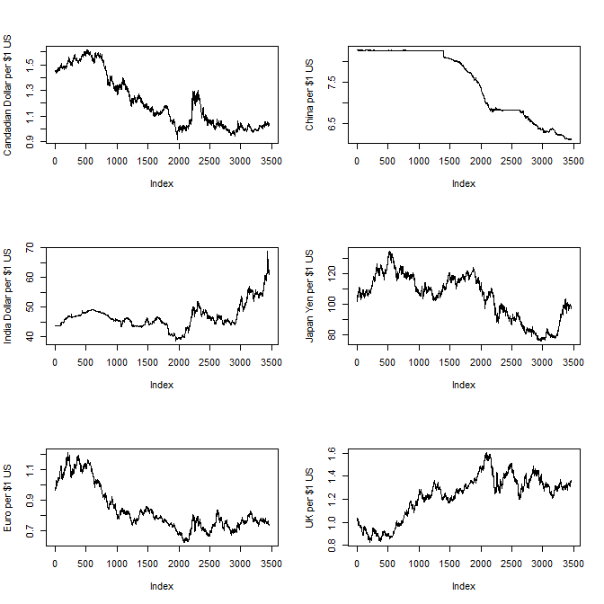

Below is the correlation of the rates themselves:

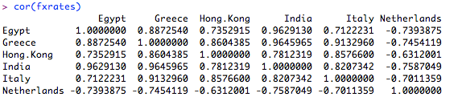

Below is the correlation of the changes of the rates:

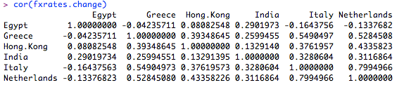

For any pair of rates we can see the correlation above. However, to establish statistical significance, we need to test this correlation against the null hypothesis that the coefficient is actually zero.

Below we regress the change in exchange rate of Egypt vs. Greece:

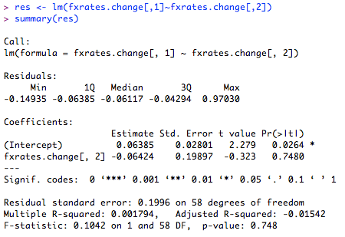

The p-value of 0.7480 indicates a 74.8% chance that the null hypothesis is valid, i.e. the changes in currency value of Greece is most likely not correlated to the change in currency value of Egypt.

**Using the data series you have, can you build a model that uses lagged values of changes in exchange rates to predict future exchange rate changes with a high level of accuracy? (This requires some experimentation and playing with the data. Ideally program R to run all possible cases.)**

n <- length(fxrates.change$canadaUS)

res <- lm(fxrates.change$canadaUS[5:n] ~ fxrates.change$canadaUS[4:(n-1)] + fxrates.change$canadaUS[3:(n-2)] + fxrates.change$canadaUS[2:(n-3)] + fxrates.change$canadaUS[1:(n-4)])

summary(res)

Looking at the lagged values of Canada:US on the current Canada:US exchange rate, we don’t see any significant relationship:

**(Intercept) -7.738e-05 1.012e-04 -0.765 0.445**

**fxrates.change$canadaUS[4:(n - 1)] 1.502e-03 1.701e-02 0.088 0.930**

**fxrates.change$canadaUS[3:(n - 2)] 1.577e-03 1.700e-02 0.093 0.926**

**fxrates.change$canadaUS[2:(n - 3)] 2.132e-02 1.701e-02 1.253 0.210**

**fxrates.change$canadaUS[1:(n - 4)] -5.679e-03 1.701e-02 -0.334 0.738**

**Residual standard error: 0.005953 on 3456 degrees of freedom**

**Multiple R-squared: 0.0004908, Adjusted R-squared: -0.000666**

**F-statistic: 0.4243 on 4 and 3456 DF, p-value: 0.7912**

More generally, we can create a linear model of one exchange rate (Canada:US in this case) as a function of all the other rates:

res <- lm(fxrates.change$canadaUS ~ fxrates.change$chinaUS + fxrates.change$indiaUS + fxrates.change$japanUS +

fxrates.change$EUUS + fxrates.change$UKUS)

summary(res)

Coefficients:

Estimate Std. Error t value Pr(>|t|)

(Intercept) 4.369e-05 9.659e-05 0.452 0.65108

fxrates.change$chinaUS 3.462e-02 9.447e-02 0.366 0.71406

fxrates.change$indiaUS 1.857e-01 1.894e-02 9.804 < 2e-16 ***

fxrates.change$japanUS -1.099e-01 1.358e-02 -8.089 8.24e-16 ***

fxrates.change$EUUS -2.178e+00 1.011e+00 -2.155 0.03124 *

fxrates.change$UKUS -2.612e+00 1.011e+00 -2.585 0.00977 **

---

Residual standard error: 0.005078 on 3459 degrees of freedom

Multiple R-squared: 0.2724, Adjusted R-squared: 0.2713

F-statistic: 259 on 5 and 3459 DF, p-value: < 2.2e-16

We can see above the Canadian rate has a correlation to changes to India, Japan, UK, and EU. What about lagged versions of each of these? This model is with one lag from each of these rates:

Coefficients:

Estimate Std. Error t value Pr(>|t|)

(Intercept) -0.0001270 0.0001131 -1.122 0.2618

fxrates.change$chinaUS[1:(n - 1)] 0.0668808 0.1106283 0.605 0.5455

fxrates.change$indiaUS[1:(n - 1)] 0.0339124 0.0221841 1.529 0.1264

fxrates.change$japanUS[1:(n - 1)] -0.0315011 0.0159039 -1.981 0.0477 *

fxrates.change$EUUS[1:(n - 1)] 1.1739568 1.1837346 0.992 0.3214

fxrates.change$UKUS[1:(n - 1)] 1.1803939 1.1832612 0.998 0.3186

---

Residual standard error: 0.005945 on 3458 degrees of freedom

Multiple R-squared: 0.002603, Adjusted R-squared: 0.001161

F-statistic: 1.805 on 5 and 3458 DF, p-value: 0.1084

**Run a vector autoregression (VAR) on the data of exchange rate changes that you have. What inferences can you make from the results?**

var6 = ar(fxrates.change,aic=TRUE,order=6)

var6$ar

> var6$ar



**QUESTION 3: (using a package)**

Below is the chart plot output from Quantmod, showing daily price of AAPL and the S&P500 index:

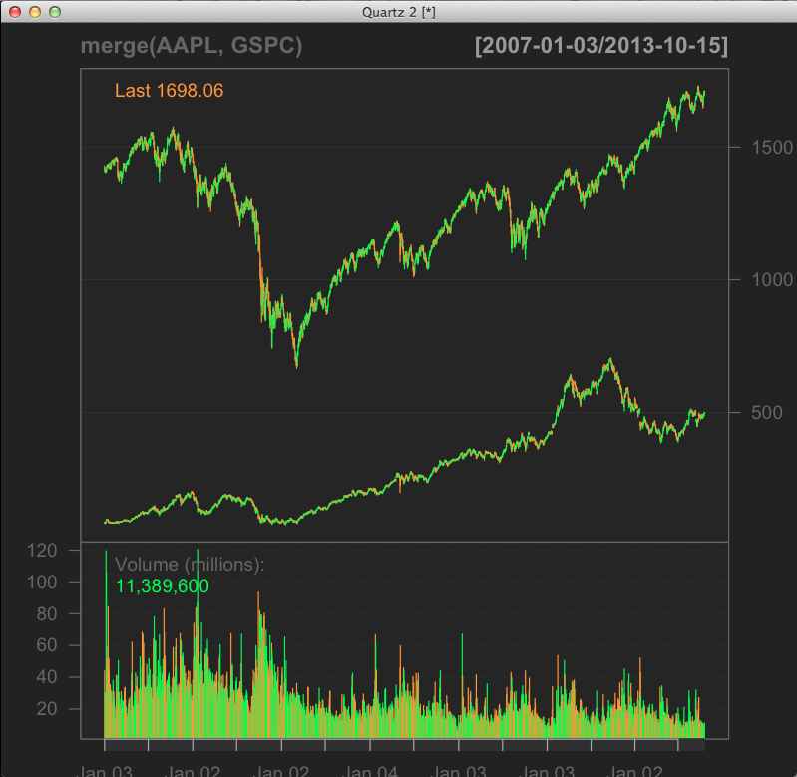

We use log returns to create a matrix of returns for both the target stock and the index:

stocks.ret <- log(stocks[2:n,]/stocks[1:(n-1),])

> head(stocks.ret)

aapl gspc

[1,] 0.021965570 0.0012275394

[2,] -0.007107179 -0.0061031642

[3,] 0.004823936 0.0022178536

[4,] 0.079857601 -0.0005168233

[5,] 0.046762330 0.0019384787

[6,] -0.012479496 0.0063198821

Below is a scatter plot of the stock return and index return. The scatterplot shows that there is most likely a significant positive correlation between AAPL stocks and the S&P500 Index. Based on the distribution of data points, AAPL looks to have a 1:1 return with the market, i.e. it has a beta of 1.

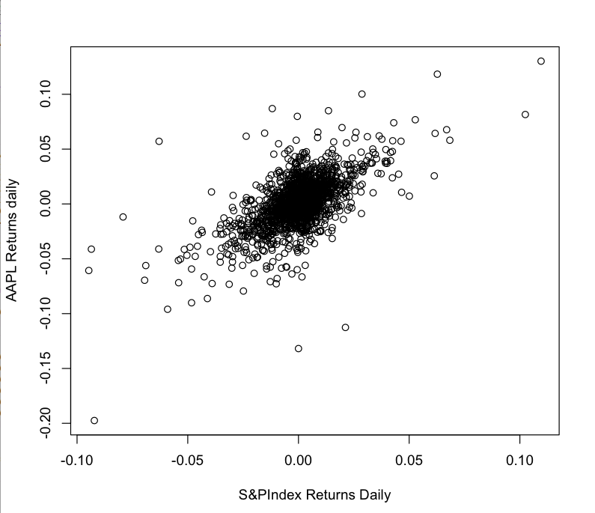

To quantify, we regressthe stock return on the index return and report the results:

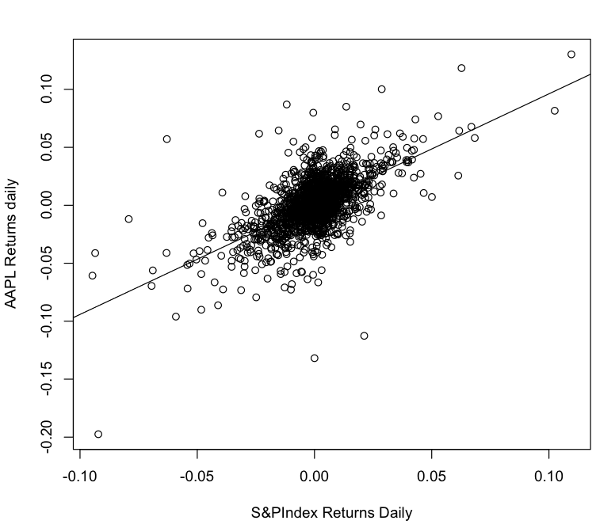

Call: lm(formula = stocks.ret[, 1] ~ stocks.ret[, 2])

Coefficients:

(Intercept) stocks.ret[, 2]

0.0009595 0.9518297

The slope of the OLS fit is close to 1. This indicates that the β value is close to 1 and the movement of the AAPL stock is very much correlated to the movement of the S&P500 Index.

The intercept, α, is near-zero which is expected for a highly-traded, efficiently-priced asset such as AAPL stock.

To quantify risk, we look at the variation of the returns. More variation means higher range of possible outcomes, hence more risk:

mean(stocks.ret[,1])

[1] 0.001060516

> var(stocks.ret[,1])

[1] 0.0005307758

> mean(stocks.ret[,2])

[1] 0.0001061047

> var(stocks.ret[,2])

[1] 0.0002241071

We calculated the mean and variance of the both AAPL and GSPC’s stock returns and found that the mean was around the same, but the variance was the much wider for AAPL than the index. This indicates that AAPL is more volatile that the index and is therefore riskier between the two.

To test for market efficiency, we can test to see if the lagged values of the independent variable contribute significantly to the regression of the dependent variable (AAPL). We first created a column of the one-day-lagged market returns, and then ran a regression including this as a new independent variable:

aapl gspc gspc_lag

[1,] 0.021965570 0.0012275394 0.0000000000

[2,] -0.007107179 -0.0061031642 0.0012275394

[3,] 0.004823936 0.0022178536 -0.0061031642

[4,] 0.079857601 -0.0005168233 0.0022178536

[5,] 0.046762330 0.0019384787 -0.0005168233

[6,] -0.012479496 0.0063198821 0.0019384787

> res = lm(stocks.ret[,1] ~ stocks.ret[,2] + stocks.ret[,3])

Coefficients:

Estimate Std. Error t value Pr(>|t|)

(Intercept) 0.0009544 0.0004381 2.179 0.0295 *

stocks.ret.rag[, 2] 0.9567642 0.0294766 32.458 <2e-16 ***

stocks.ret.rag[, 3] 0.0417314 0.0294786 1.416 0.1571

---

Signif. codes: 0 ‘***’ 0.001 ‘**’ 0.01 ‘*’ 0.05 ‘.’ 0.1 ‘ ’ 1

Residual standard error: 0.0181 on 1705 degrees of freedom

Multiple R-squared: 0.3833, Adjusted R-squared: 0.3825

F-statistic: 529.8 on 2 and 1705 DF, p-value: < 2.2e-16

From the linear model summary above, we see there is not a statistically significant relationship between the one-day-lagged return of the market to AAPL, thus we maintain our null hypothesis that this coefficient is zero.

From *Investopedia*, Autocorrelation is “[a] mathematical representation of the degree of similarity between a given time series and a lagged version of itself over successive time intervals. It is the same as calculating the correlation between two different time series, except that the same time series is used twice - once in its original form and once lagged one or more time periods. The term can also be referred to as "lagged correlation" or "serial correlation".”

To test for lagged autocorrelation, we can test if today’s AAPL returns has a correlation with its own return from yesterday, thus is our dependent variable correlated to lagged values of itself? To test for this we regress today’s returns against 4 lags:

> res <- lm(logRets$aapl[5:n] ~ logRets$aapl[4:(n-1)] + logRets$aapl[3:(n-2)] + logRets$aapl[2:(n-3)] + logRets$aapl[1:(n-4)])

Coefficients:

Estimate Std. Error t value Pr(>|t|)

(Intercept) 0.0002031 0.0020497 0.099 0.9211

logRets$aapl[4:(n - 1)] -0.1081782 0.0098778 -10.952 < 2e-16 ***

logRets$aapl[3:(n - 2)] -0.0619467 0.0099279 -6.240 4.56e-10 ***

logRets$aapl[2:(n - 3)] -0.0392087 0.0099279 -3.949 7.89e-05 ***

logRets$aapl[1:(n - 4)] 0.0219478 0.0098778 2.222 0.0263 *

---

Signif. codes: 0 ‘***’ 0.001 ‘**’ 0.01 ‘*’ 0.05 ‘.’ 0.1 ‘ ’ 1

Residual standard error: 0.2075 on 10244 degrees of freedom

(1 observation deleted due to missingness)

Multiple R-squared: 0.01576, Adjusted R-squared: 0.01537

F-statistic: 41 on 4 and 10244 DF, p-value: < 2.2e-16

We can see from the results that the first 4 lags are all arguably statistically significant based on the p-values. However if we perform a similar test on the entire S&P500 index, there is no such correlation:

Coefficients:

Estimate Std. Error t value Pr(>|t|)

(Intercept) 1.937e-05 2.184e-03 0.009 0.993

logRets$gspc[4:(n - 1)] -6.653e-02 9.880e-03 -6.734 1.74e-11 ***

logRets$gspc[3:(n - 2)] -6.924e-03 9.902e-03 -0.699 0.484

logRets$gspc[2:(n - 3)] -7.529e-03 9.902e-03 -0.760 0.447

logRets$gspc[1:(n - 4)] 5.594e-03 9.880e-03 0.566 0.571

---

Signif. codes: 0 ‘***’ 0.001 ‘**’ 0.01 ‘*’ 0.05 ‘.’ 0.1 ‘ ’ 1

Residual standard error: 0.2211 on 10244 degrees of freedom

(1 observation deleted due to missingness)

Multiple R-squared: 0.004504, Adjusted R-squared: 0.004115

F-statistic: 11.59 on 4 and 10244 DF, p-value: 2.187e-09

The single stock AAPL had a much higher degree of autocorrelation when compared to the market as a whole. Given efficient market theory, we would expect the single asset to demonstrate momentum instead of the entire market.

We can automate this test for autocorrelation using the Durbin-Watson test in the r “car” library:

durbin.watson(logRets$aapl,max.lag=10)

[1] 2.201417 2.096316 2.059938 1.935752 1.999292 2.038623 2.058636 1.995265

[9] 1.977384 1.943195

The DW values which are <2 or >2 could indicate potential auto-correlation, and as expected the first four lags show potential based on the DW test.

QUESTION 4 (using Twitter)

- We will use the twitteR package (<http://cran.r-project.org/web/packages/twitteR/index.html>)

- Pick some twitter feeds and extract tweets from them.

After authorizing using the steps outline in the lecture notes, we are able to search for tweets in a few different ways:

#### some examples of twitter searches, retrieving m tweets

m <- 500

# search for m tweets based on string

#tweets <- searchTwitter("#beer", n=m)

#tweets <- searchTwitter("#GOOG", n=m)

## Search between two dates

# tweets <- searchTwitter("charlie sheen", since="2011-03-01", until="2011-03-02")

## geocoded results

#tweets <- searchTwitter("big data", geocode="37.3628,-121.9292,50mi", n=m)

# get m tweets from user

#user <- "username"

#userInfo <- getUser(user,cainfo="cacert.pem")

#tweets <- userTimeline(user, n=m,cainfo="cacert.pem")

It is very helpful to use the twitteR function twListToDF(), which will create a data frame from the returned tweets:

# create a data frame

tweets_df = twListToDF(tweets)

In the following analysis, we choose to follow the @WSJ user:

# get m tweets from user

user <- "WSJ"

userInfo <- getUser(user,cainfo="cacert.pem")

tweets <- userTimeline(user, n=m,cainfo="cacert.pem")

# create a plot of time series of cumulative tweets:

n <- length(tweets_df$created)

y <- seq(1,n)

y <- y[n:1]

plot(y ~ tweets_df$created, main="Tweets over Time, WSJ", xlab="Date and Time",ylab="Cumulative Tweets")

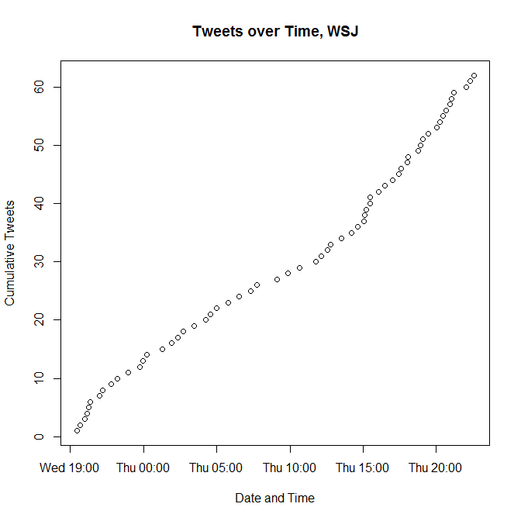

The Wall Street Journal is a regular tweeter, as displayed on the time series plot above. On average they tweeted *2.3 times per hour* over this analysis window:

# what is the time window for which we got tweets?

timeWindow <- difftime(max(tweets_df$created),min(tweets_df$created),units="hours")

# what is the average frequency of tweets per hour

tweetFreq <- length(y)/as.numeric(timeWindow)

Next, we extracted tweets based on a hashtag *#shutdown*:

tweets <- searchTwitter("#shutdown", n=m)

On average there were *1527.5 tweets per hour* using the hashtag #shutdown. The last 200 tweets (the max we could pull) only happened in the last 10 minutes or so:

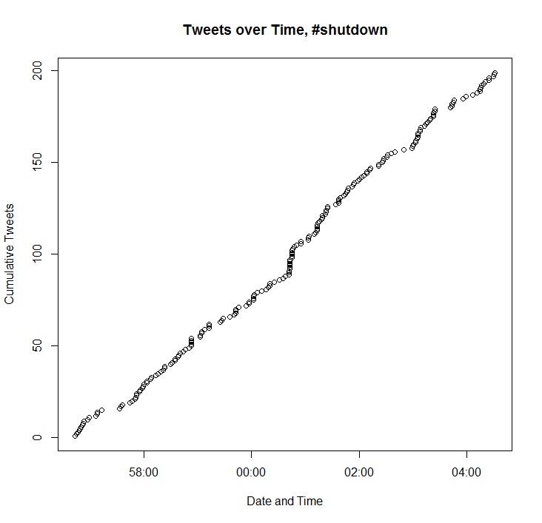

To further analyze this tweet stream, we used the Harvard General Inquirer to score the sentiment of tweets from -1 to 1. Each tweet is cleaned and compared to the dictionary, and assigned a score from -1 to 1. For example, here is the distribution of 164 most recent #shutdown tweets:

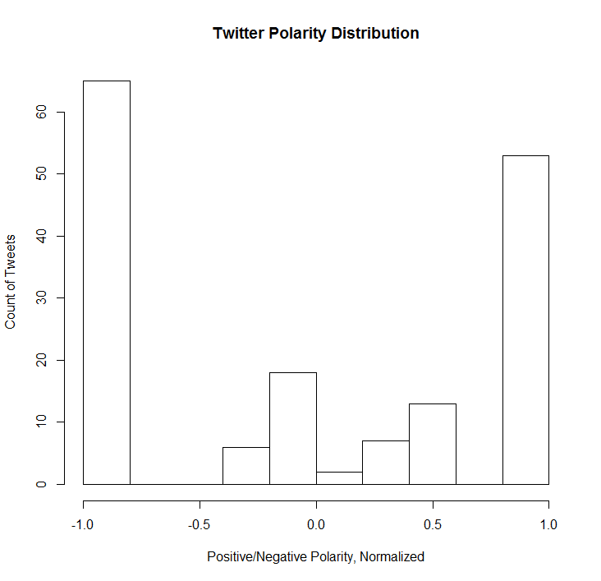

We can also see how this sentiment has trended over time, with a slight uptick towards the end. This is approximately 15 minutes worth of tweets:

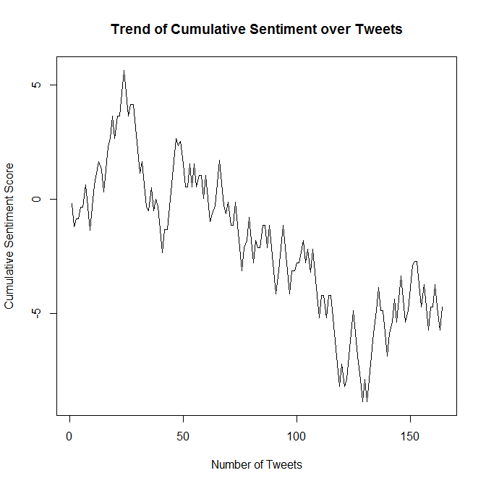

Closely associated, here is the recent cumulative sentiment for search term “boehner”:

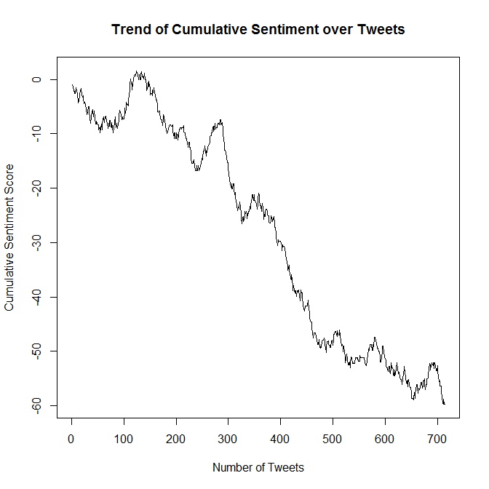

Compare this against a cumulative tweet sentiment for something positive, like “candy”:

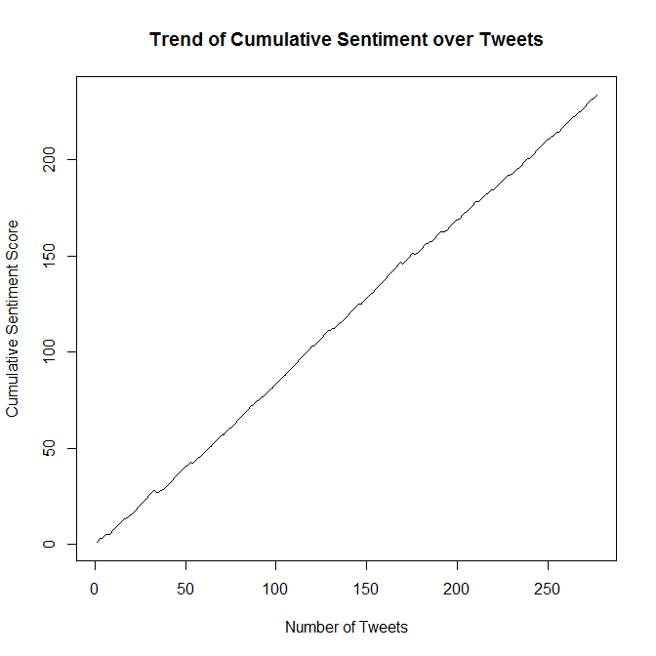

**Appendix – Code for problems**

#Q1

# read in the txt file

# Customer ID, Age, Sex, Location, Action, Time the action was performed, Is the remote hardware setup with the app?

data <- read.csv("e:/datamining/Peel/0000_part_00.csv", header=FALSE, col.names=c("ID", "Age", "Sex", "Location", "Action", "Time", "Hardware" ))

data1 <- read.csv("e:/datamining/Peel/0001_part_00.csv", header=FALSE, col.names=c("ID", "Age", "Sex", "Location", "Action", "Time", "Hardware" ))

data2 <- read.csv("e:/datamining/Peel/0002_part_00.csv", header=FALSE, col.names=c("ID", "Age", "Sex", "Location", "Action", "Time", "Hardware" ))

data3 <- read.csv("e:/datamining/Peel/0003_part_00.csv", header=FALSE, col.names=c("ID", "Age", "Sex", "Location", "Action", "Time", "Hardware" ))

# bind all rows into a singe frame

data <- rbind(data,data1,data2, data3)

# change Time column to Date and time type

data$Time <- as.POSIXct(data$Time)

# Sort By ascending ID then by ascending time

dataSorted <- data[with(data, order(ID, Time)), ]

summary(dataSorted)

# How many unique IDs are there? Create a vector of users

IDlist <- unique(data$ID)

n <- length(IDlist)

# 12991 unique user IDs

# initialize a user data frame

user <-NULL

# initialize data types

user$Location <- factor(levels=levels(dataSorted$Location))

user$Sex <- factor(levels=levels(dataSorted$Sex))

user$Hardware <- factor(levels=levels(dataSorted$Hardware))

user$FirstAction <- as.POSIXct(dataSorted$Time[1])

user$LastAction <- as.POSIXct(dataSorted$Time[1])

user$TotalTime <- numeric(1)

user$ID <- IDlist

# create STATIC user data frame with demographics and characteristics from master data

for (i in 1:n) {

# get a subset of data and store in a temporary "oneUserData" frame

oneUserData <- subset(dataSorted, dataSorted$ID==IDlist[i])

# generate single data points for each user from complete data, usually by taking the first entry of the subset from each column

user$Age[i] <- oneUserData$Age[1]

user$Location[i] <- oneUserData$Location[1]

user$Sex[i] <- oneUserData$Sex[1]

user$Hardware[i] <- oneUserData$Hardware[1]

user$LifeActions[i] <- length(oneUserData$Action)

user$FirstAction[i] <- min(oneUserData$Time)

user$LastAction[i] <- max(oneUserData$Time)

user$TotalTime[i] <- difftime(user$LastAction[i],user$FirstAction[i], units="days")

}

# re-assemble user data back into a single data frame

user <- data.frame(user)

str(user)

head(user)

### Usage information

hist(user$TotalTime, main="Total Activity Span", xlab="Time from First to Last Usage, days")

#### AGE INFORMATION

# replace 0 or 100 with NA

user$Age[user$Age==0] <- NA

user$Age[user$Age==100] <- NA

# remove NA values into a clean vector

withAge <- na.omit(user$Age)

# How many users have specified an age as percentage of total?

haveAge <- length(withAge)/length(user$Age)

print(haveAge)

print("report Age")

hist(withAge, xlab="Age, years", ylab="Count", main="Age Distribution of Users Reporting")

lines(h=mean(withAge))

mean(withAge)

median(withAge)

mode(withAge)

#### SEX INFORMATION

# replace blank with NA

user$Sex[user$Sex==""] <- NA

# Create a new vector with just the values input and plot histogram

withSex <- na.omit(user$Sex)

haveSex <- length(withSex)/length(user$Sex)

print(haveSex)

print("report Sex")

# Pie Chart from data frame with Appended Sample Sizes

mytable <- table(withSex)

lbls <- paste(names(mytable), "\n", mytable, sep="")

pie(mytable, labels = lbls,

main="User Sex, of Those Reporting")

#### User hardware information

haveHardware <- length(user$Hardware[user$Hardware=="Y"])/length(user$Hardware)

print(haveHardware)

print("Have Hardware")

mytable <- table(user$Hardware)

lbls <- paste(names(mytable), "\n", mytable, sep="")

pie(mytable, labels = lbls,

main="User Hardware?")

# Location Information

user$Location[user$Location==""]<-NA

ActualLocations <- na.omit(user$Location)

haveLocation <- length(ActualLocations)/length(user$Location)

print(haveLocation)

print("Have Location")

ActualLocations <- sort(ActualLocations)

mytable <- table(ActualLocations)

# Action information

bins=seq(0,300,by=10)

hist(user$LifeActions[user$LifeActions<300], breaks=bins, freq=FALSE, xlab="Lifetime # of Actions", ylab="Density of Users", main="Distribution of Lifetime User Actions")

#Q2

#QUESTION 2 (Find relationships)

#Go to the web page for Federal Reserve data at:http://research.stlouisfed.org/

#Download exchange rate data for 6 countries of your choice versus the US dollar. Summarize this data and plot the series. Provide a brief description.

library("quantmod")

library("tseries")

library("car")

library("stats")

date_range <- "2000-01-01::2013-10-15"

# Canada, China, India, Japan to $1 US

getSymbols(c("DEXCAUS", "DEXCHUS", "DEXINUS", "DEXJPUS", "DEXUSEU", "DEXUSUK"), src='FRED')

# convert xts from getSymbols to numeric

canadaUS <- as.numeric(DEXCAUS[date_range])

chinaUS <- as.numeric(DEXCHUS[date_range])

indiaUS <- as.numeric(DEXINUS[date_range])

japanUS <- as.numeric(DEXJPUS[date_range])

USEU <- as.numeric(DEXUSEU[date_range])

USUK <- as.numeric(DEXUSUK[date_range])

EUUS <- 1/USEU

UKUS <- 1/EUUS

# create data frame

fxrates <- data.frame(canadaUS, chinaUS, indiaUS, japanUS, EUUS, UKUS)

fxrates <- na.omit(fxrates)

par(mfrow=c(3,2))

plot(fxrates$canadaUS, ylab="Candadian Dollar per $1 US", type="l")

plot(fxrates$chinaUS, ylab="China per $1 US", type="l")

plot(fxrates$indiaUS, ylab="India Dollar per $1 US", type="l")

plot(fxrates$japanUS, ylab="Japan Yen per $1 US", type="l")

plot(fxrates$EUUS, ylab="Euro per $1 US", type="l")

plot(fxrates$UKUS, ylab="UK per $1 US", type="l")

#Present the correlation table of exchange rates.

cor(fxrates)

#Present the correlation table of changes in exchange rates.

# create matrix of changes (percent changes)

n <- dim(fxrates)[1]

fxrates.change <- (fxrates[2:n,]-fxrates[1:(n-1),])/fxrates[1:(n-1),]

cor(fxrates.change)

#Pick your favorite pair of exchange rates and say whether the correlation of exchange rate changes in statistically significant or not. How would you establish this?

#Regress one series of exchange rate changes on another, and describe the output (R-square, t-statistics, f-statistic, etc.) Is there any economic conclusion that you can infer from the regression?

res <- lm(fxrates.change$canadaUS ~ fxrates.change$EUUS)

summary(res)

# Using the data series you have, can you build a model that uses lagged values of changes in exchange rates to predict future exchange rate changes with a high level of accuracy? (This requires some experimentation and playing with the data. Ideally program R to run all possible cases.)

# this is one rate against all the others, current rate

n <- length(fxrates.change$canadaUS)

res <- lm(fxrates.change$canadaUS ~ fxrates.change$chinaUS + fxrates.change$indiaUS + fxrates.change$japanUS +

fxrates.change$EUUS + fxrates.change$UKUS)

summary(res)

# this is one rate against all the others, ;agged once

res <- lm(fxrates.change$canadaUS[2:n] ~ fxrates.change$chinaUS[1:(n-1)] + fxrates.change$indiaUS[1:(n-1)] + fxrates.change$japanUS[1:(n-1)] +

fxrates.change$EUUS[1:(n-1)] + fxrates.change$UKUS[1:(n-1)])

summary(res)

# Use a DurbinWatson to test for auto-correlation of Canada:US exchange rate

res <- lm(fxrates.change[2:n,1] ~ fxrates.change[1:(n-1),1])

summary(res)

durbin.watson(res,max.lag=10)

#Run a vector autoregression (VAR) on the data of exchange rate changes that you have. What inferences can you make from the results?

var6 = ar(fxrates.change,aic=TRUE,order=6)

var6$order

var6$ar

#Q3

#QUESTION 2 (Find relationships)

#Go to the web page for Federal Reserve data at:http://research.stlouisfed.org/

#Download exchange rate data for 6 countries of your choice versus the US dollar. Summarize this data and plot the series. Provide a brief description.

library("quantmod")

library("tseries")

library("car")

library("stats")

date_range <- "2000-01-01::2013-10-15"

# get symbols

getSymbols(c("AAPL","^GSPC"))

# convert xts from getSymbols to numeric

aapl <- as.numeric(AAPL[date_range])

gspc <- as.numeric(GSPC[date_range])

# create data frame

stocks <- data.frame(aapl,gspc)

stocks <- na.omit(stocks)

#Present the correlation table of changes in exchange rates.

# create matrix of changes (percent changes)

n <- dim(stocks)[1]

rets <- (stocks[2:n,]-stocks[1:(n-1),])/stocks[1:(n-1),]

logRets <- log(stocks[2:n,]/stocks[1:(n-1),])

# linear regression of returns

res <- lm(logRets$aapl ~ logRets$gspc)

summary(res)

# Using the data series you have, can you build a model that uses lagged values of changes in exchange rates to predict future exchange rate changes with a high level of accuracy? (This requires some experimentation and playing with the data. Ideally program R to run all possible cases.)

res <- lm(logRets$aapl[5:n] ~ logRets$aapl[4:(n-1)] + logRets$aapl[3:(n-2)] + logRets$aapl[2:(n-3)] + logRets$aapl[1:(n-4)])

summary(res)

res <- lm(logRets$gspc[5:n] ~ logRets$gspc[4:(n-1)] + logRets$gspc[3:(n-2)] + logRets$gspc[2:(n-3)] + logRets$gspc[1:(n-4)])

summary(res)

# Use a DurbinWatson to test for auto-correlation

dwres <- durbin.watson(logRets$aapl,max.lag=10)

n <- length(logRets$aapl)

res <- lm(logRets$aapl[2:n] ~ logRets$aapl[1:(n-1)])

durbin.watson(res,max.lag=10)

#Q4

library("plyr")

library("twitteR")

library("ROAuth")

library("RCurl")

library("tm")

## resoution for SSL verification issue - disable it

opts <- list(

capath = system.file("CurlSSL", "cacert.pem", package = "RCurl"),

ssl.verifypeer = FALSE);

options(RCurlOptions = opts)

### SIMPLE HARVARD POS NEGATIVE DICTIONARY

# Read in HI Dictionary from TXT #every word is tagged by psychometric tags

HIDict = readLines("e:/Dropbox/FNCE 696/Data/inqdict.txt")

# create a dictionary of Pos-tagged words

dict_pos <- HIDict[grep("Pos",HIDict)] #return index for every line that contains "Pos"

poswords <- NULL

for (s in dict_pos) {

s <- strsplit(s,"#")[[1]][1] #split at hash to remove instance ID of same words

poswords <- c(poswords, strsplit(s," ")[[1]][1]) #returns list, take first element of that array

}

poswords <- tolower(poswords)

# create a dictionary of Neg-tagged words

dict_neg <- HIDict[grep("Neg",HIDict)] #return index for every line that contains "Pos"

negwords=NULL

for (s in dict_neg) {

s <- strsplit(s,"#")[[1]][1] #split at hash to remove instance ID of same words

negwords <- c(negwords, strsplit(s," ")[[1]][1]) #returns list, take first element of that array

}

negwords <- tolower(negwords)

######################

#### AUTHORIZATION CODE

download.file(url="http://curl.haxx.se/ca/cacert.pem", destfile="cacert.pem")

cKey <- *REMOVED*

cSecret <- *REMOVED*

reqURL <- "https://api.twitter.com/oauth/request_token"

authURL <- "https://api.twitter.com/oauth/authorize"

accURL <- "https://api.twitter.com/oauth/access_token"

cred <- OAuthFactory$new(consumerKey=cKey, consumerSecret=cSecret,requestURL=reqURL,

accessURL=accURL,authURL=authURL)

cred$handshake(cainfo="cacert.pem")

registerTwitterOAuth(cred)

save(list="cred", file="twitteR_credentials")

load("twitteR_credentials")

registerTwitterOAuth(cred)

#### some examples of twitter searches, retrieving m tweets

m <- 1000

# search for m tweets based on string

#searchTwitter("#beer", n=m)

tweets <- searchTwitter("#GAP", n=m)

## Search between two dates

#searchTwitter("charlie sheen", since="2011-03-01", until="2011-03-02")

## geocoded results

#tweets <- searchTwitter("big data", geocode="37.3628,-121.9292,50mi", n=m)

# get m tweets from user

#user <- "WSJ"

#userInfo <- getUser(user,cainfo="cacert.pem") #Works correctly

#tweets <- userTimeline(user, n=m,cainfo="cacert.pem")

# create a data frame

tweets_df = twListToDF(tweets)

n <- length(tweets_df$created)

y <- seq(1,n)

y <- y[n:1]

plot(y ~ tweets_df$created, main="Tweets over Time, #shutdown", xlab="Date and Time",ylab="Cumulative Tweets")

# what is the time window for which we got tweets?

timeWindow <- difftime(max(tweets_df$created),min(tweets_df$created),units="hours")

# what is the average frequency of tweets per hour

tweetFreq <- length(y)/as.numeric(timeWindow)

# pull out only text from twitter data frame

tweets <- lapply(tweets, function(t)t$getText())

Score <- NULL

# score tweets for sentiment

for (i in 1:m) {

text <- tweets[i]

txtCLEAN <- tolower(text)

txtCLEAN <- removePunctuation(txtCLEAN)

txtCLEAN <- strsplit(txtCLEAN, " ")

txtCLEAN <- unlist(txtCLEAN)

## POSITIVE WORD COUNT

posmatch <- match(txtCLEAN, poswords) #take two vectors/arrays and give back matches

numPosMatch <- length(posmatch[which(posmatch>0)])

#### NEGATIVE WORD COUNT

negmatch <- match(txtCLEAN, negwords)

numNegMatch <- length(negmatch[which(negmatch>0)])

Score[i] <- (numPosMatch - numNegMatch)/(numPosMatch + numNegMatch)

#print(Score[i])

}

# Remove NaN results

Score <- na.omit(Score)

# plot distribution of polarity score

hist(Score, xlab="Positive/Negative Polarity, Normalized", ylab="Count of Tweets", main="Twitter Polarity Distribution")

mean(Score)

m <- length(Score)

Score <- Score[m:1]

netScore <- NULL

for (n in 1:length(Score)) {

netScore[n] <- sum(Score[1:n])

}

plot(netScore, type="l", main="Trend of Cumulative Sentiment over Tweets", xlab="Number of Tweets", ylab="Cumulative Sentiment Score")w